Loss function

In deep learning, a loss function is a mathematical function that measures the difference between the predicted output of a model and the actual target values.
Types of Loss Functions:
Loss functions vary based on the type of problem: regression, classification, or other specialized tasks.
1. Regression Loss Functions
Used when the target variable is continuous.
- Mean Squared Error (MSE):
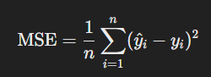
  - Penalizes larger errors more severely.
  - Suitable for predicting continuous values.
- Mean Absolute Error (MAE):
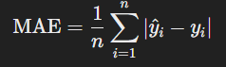
  - Less sensitive to outliers than MSE.
- Huber Loss: Combines MSE and MAE, robust to outliers.
2. Classification Loss Functions
Used when the target variable is categorical.

- Binary Cross-Entropy (Log Loss):
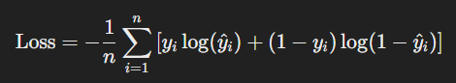
  - Used for binary classification problems.
  - Measures the dissimilarity between predicted probabilities and actual labels.

- Categorical Cross-Entropy:
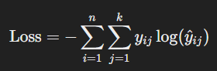
  - Generalization of binary cross-entropy for multi-class classification.

Key Points:
Relu, Softmax, CategoricalCrossEntropy => multi-class
Relu, Sigmoid, BinaryCrossEntropy => Binary class
Relu, Linear Activation, {MSE, MAE, Huber Loss} =>Linear Regression

Optimizers
Optimizers are algorithms or methods used to minimize the loss function by updating the weights and biases of a neural network during training.

Role of Optimizers
- Minimize Loss:
  - Optimizers adjust the parameters (weights and biases) to minimize the difference between predicted and actual values (i.e., minimize the loss function).
- Improve Convergence:
  - They help the model converge to an optimal or near-optimal solution efficiently.
- Handle High-Dimensional Spaces:
  - Optimizers navigate the complex, high-dimensional loss landscape.

1. Gradient Descent (GD)
- Description:
  - Updates the parameters in the opposite direction of the gradient of the loss function.
θ=θ−η⋅∇J(θ)
  - θ: Model parameters (weights).
  - η: Learning rate.
  - ∇J(θ): Gradient of the loss function.
- Variants:
  - Batch Gradient Descent:
    - Uses the entire dataset to compute gradients.
    - Slow for large datasets.
  - Stochastic Gradient Descent (SGD):
    - Updates weights using a single data point at a time.
    - Faster but noisier.
    - Introduces noise, which can help escape local minima.
  - Mini-Batch Gradient Descent:
    - Updates weights using small batches of data.
    - Balances speed and stability.

Momentum
- Momentum enhances gradient descent by adding inertia, which accelerates convergence and smoothens oscillations.
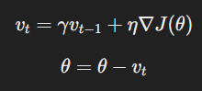
  - vt​: Velocity term.
  - γ: Momentum coefficient (e.g., 0.9).
  - η: Learning rate.
• Benefits:
- Speeds up convergence along gentle slopes.
- Reduces oscillations in steep directions.
• Drawbacks:
- May overshoot minima if momentum is too high.

- Adaptive optimizers
- Adaptive optimizers are optimization algorithms that adjust the learning rate dynamically for each parameter during training.
- Dynamic Learning Rate: They adjust the learning rate for each parameter individually, making training faster and more stable.

  - Adagrad
- Key Idea:
  - Adapts learning rates based on the magnitude of past gradients.

- Formula:
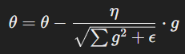
  - g: Gradient (a partial derivative of the loss function with respect to the parameter).
  - Summation(g^2): summation all previous weight
  - ϵ: Small constant for numerical stability.

  - RMSprop
- Key Idea:
  - Improves upon Adagrad by using an exponentially decaying average of squared gradients instead of summing them.
- Formula:
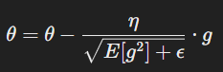
  - E[g2]: Exponentially weighted moving average of squared gradients.

  - Adam (Adaptive Moment Estimation) optimizer
The Adam (Adaptive Moment Estimation) optimizer combines concepts from momentum and adaptive learning rates.
Formulas:
- First Moment (Mean):
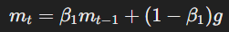
  - mt​: The exponentially weighted average of past gradients, representing the "mean" or first moment of gradients.
  - β1​: Decay rate for the moving average of gradients (0.9).
  - g: Current gradient (i.e., partial derivative of the loss function with respect to the parameter).
- Second Moment (Variance):
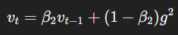
  - vt​: The exponentially weighted average of past squared gradients, representing the "variance" or second moment.
  - β2​: Decay rate for the moving average of squared gradients (typical value: 0.999).
  - g2: Square of the current gradient (element-wise).
- Bias Correction:
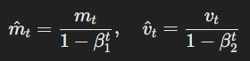
  - β1t​​: Powers of β1​ and β2​, decreasing as t (iteration count) increases.
  - m^t​: Bias-corrected first moment (mean).
  - v^t​: Bias-corrected second moment (variance).
- Update Rule:
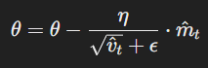
  - θ: Model parameters (weights and biases).
  - η: Learning rate.
  - m^t: Bias-corrected first moment.
  - v^t​​: Square root of the bias-corrected second moment.
  - ϵ: Small constant added for numerical stability (eg,10^{-8})
- Advantages:
  - Fast convergence.
  - Works well for large datasets and deep networks.
- Disadvantages:
  - Can sometimes overfit or fail to generalize well.

